**Create Functional component:(5)**

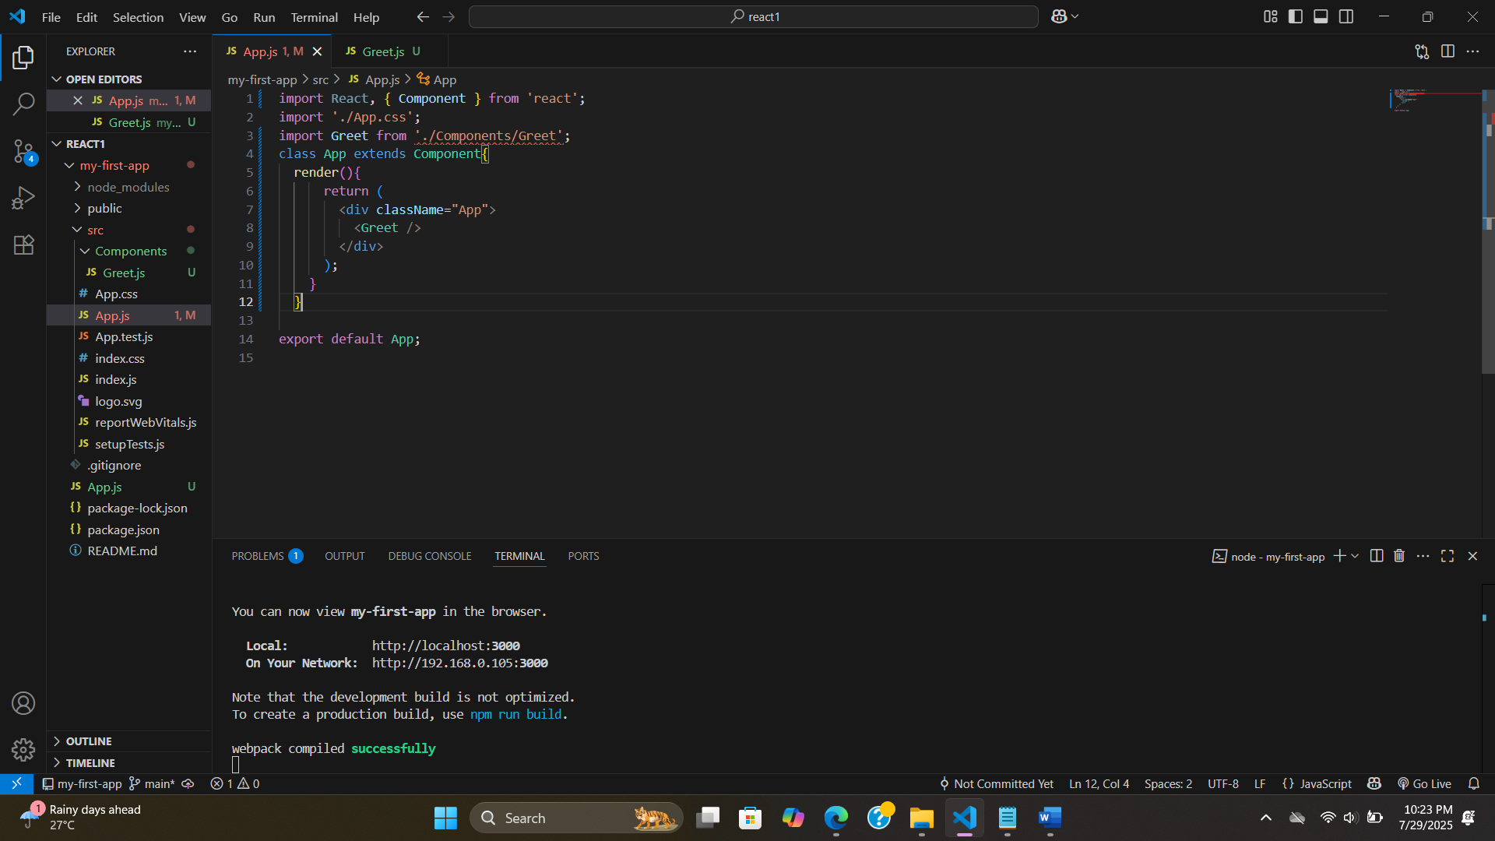

* **open derectory named component then oben a js file for the page then in page.js'export default pagename;' then in App.js 'import pagename from './component/page name'' and also import React, { component } from 'React'**

export default Greet;

**Greet.js:**

import React from "react";

function Greet(){

return <h1> Hello world<h1>**// this is not html this is jxs**

}

export default Greet;

**App.js:**

import React, { Component } from 'react';

import './App.css';

import Greet from './Components/Greet';

class App extends Component{

render(){

return (

<div className="App">

<Greet />

</div>

);

}

}

export default App;

**With ArrowFunction and export not default:**

**Class Component:(6)**

**#use Functional component as much as possible,absence if “this” keyword as much as possible**

**Solution without using state.**

**HOOKS (Kind a Component):(7)**

* Its allow state and react other features without writing a class.
* No breaking change.
* Completely opt-in & 100% backwards-compatible**.**

**JSX:(8)**

With JSX:

Without JSX:

**Props:(9)**

**Add first props:**

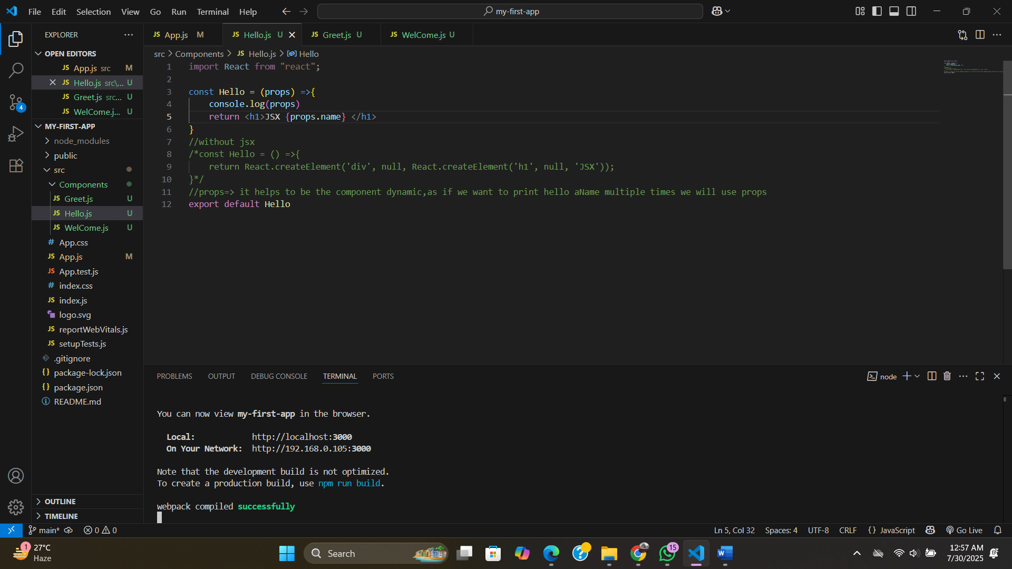

**

**Chapters:**

**Props with Class Component:**

**#props are immutable(the value cannot be change)**